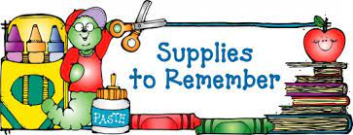

Kindergarten

headphones for computer use

jumbo beginner pencils

8 pack jumbo crayons

2 red or blue poly 3 prong pocket folders

blunt tip scissors

book bag

3 large glue sticks

3 pink erasers

pencil box

1 pack sealable sandwich or gallon bags

**Wish List**

construction paper

play doh

**Supplies to have at home**

pencils/sharpener

crayons

glue sticks

blunt tip scissors